**HAPP-Assignment 3: Matching with Signature Data**

1. **Objective**

The goal of this assignment is to calculate the similarity between two online handwritten signatures using linear matching and dynamic programming (DP) matching methods. Additionally, the signature data is visualized to highlight the matching correspondences.

1. **Methods**
2. **Data Reading**

The .sdt signature files are parsed to extract strokes, where each stroke consists of a sequence of (x, y) coordinates.

1. **Distance Calculation**

* **Linear Matching:** Each stroke is matched point-to-point in sequence. The distance is computed as the average Euclidean distance between corresponding points of the same stroke.
* **DP Matching:** A dynamic programming algorithm is used to match strookes by finding an optimal alignment path with minimal cumulative cost, allowing for more flexible correspondence.

1. **Visualization**

* The original signatures are plotted in different colors (blue and red).
* For both linear and DP methods, gray dotted lines are drawn between corresponding points.
* All plots are inverted in the y-axis for natural writing orientation.

1. **Language and Compilation**

The program is written in Python and compiled into a standalone .exe using PyInstaller.

To compile the script into .exe, run:

pyinstaller –onefile SignatureMatching.py

* Libraries Used:
  + numpy – for numerical computations
  + matplotlib – for visualization
  + os – for file path operations

1. **How to Use**

* **Method 1: Run the Python Soutce Code**

1. Place SignatureSampleData folder in the same directory as SignatureMatching.py.
2. Open a terminal in the directory.
3. Run the following command: python SignatureMatching.py
4. The program will automatically plot and save the results in an output_images folder.

* **Method 2: Run the Executable File**

1. Place SignatureSampleData folder in the same directory as SignatureMatching.exe.
2. Double-click the .exe file to execute the program.
3. The output images will be saved in the output_images folder.
4. **Result Details**

The program was tested on two datasets: SignatureSampleData and SimpleData. The computed matching distances for each method are shown below:

* SignatureSampleData

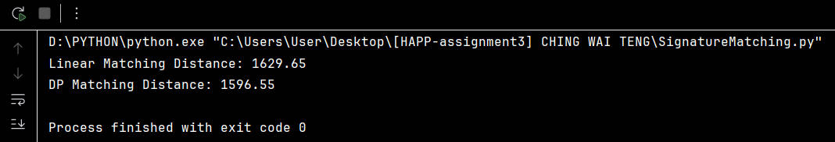

* + Linear Matching Distance: 1629.65
  + Dynamic Programming (DP) Matching Distance: 1596.55
* SimpleData

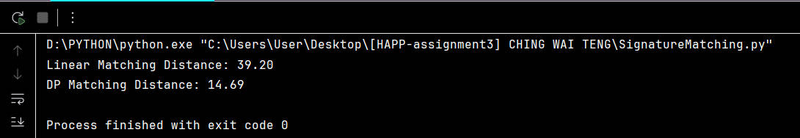

* + Linear Matching Distance: 39.20
  + Dynamic Programing (DP) Matching Distance: 14.69

These results show that DP Matching consistently yield lower distances than Linear Matching. This is expected, as DP Matching allows more flexible alignment between strokes and points, leading to more accurate similarity measurements.

1. **Output images**

* Screenshots showing the program execution can be found in the output_images/ folder.
* Original

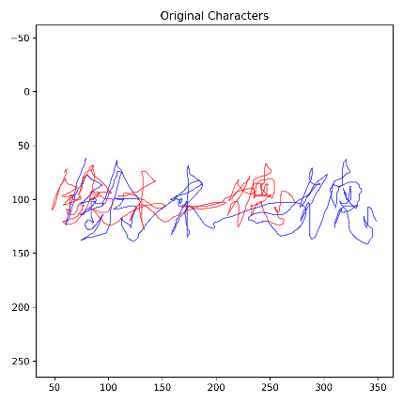 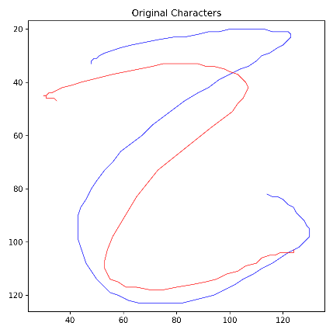

* Linear Matching

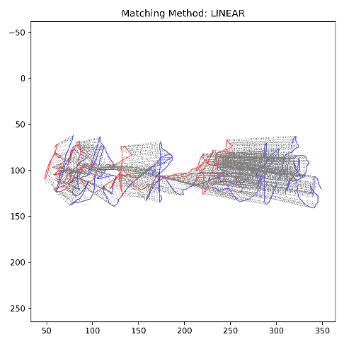 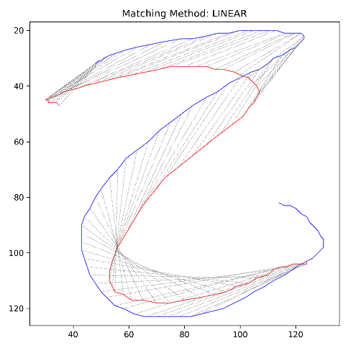

* DP Matching

